**Organs of a Plant**

Organ:

Function:

Xylem:

Phloem:

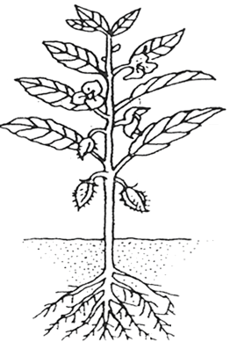

Organ:

Function:

How it works:

Organ:

Function:

How it works:

**Photosynthesis**

Formula equation:

Word equation: